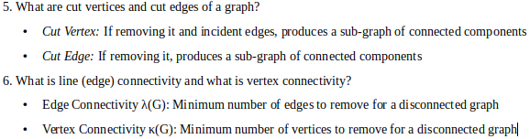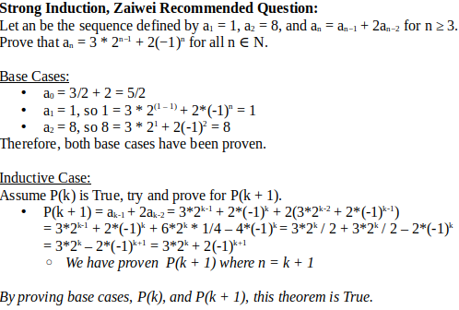

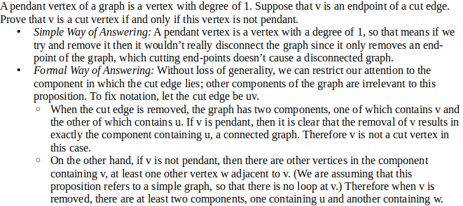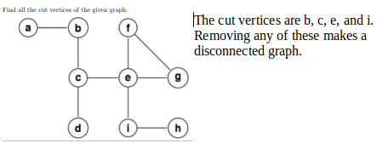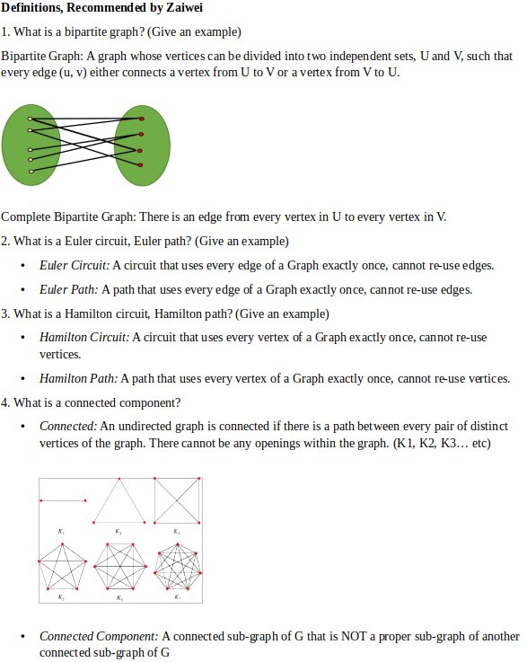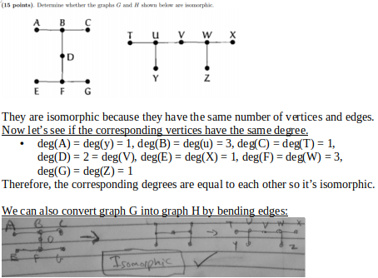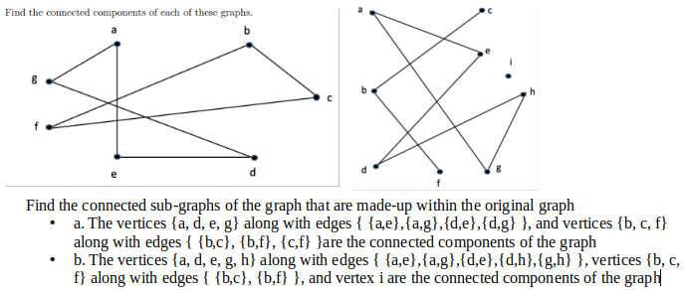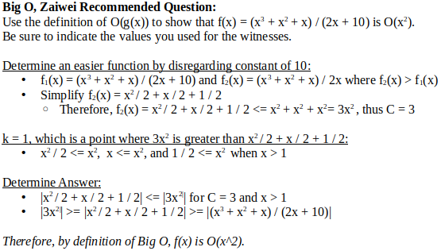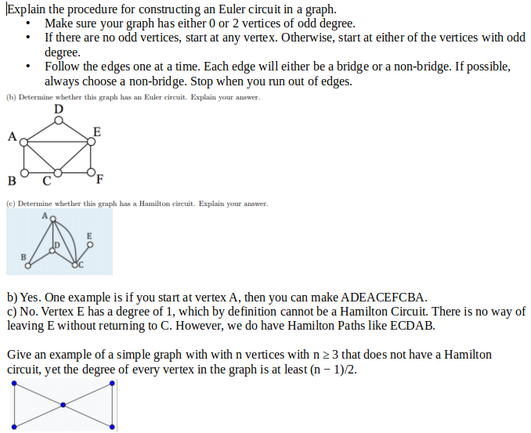

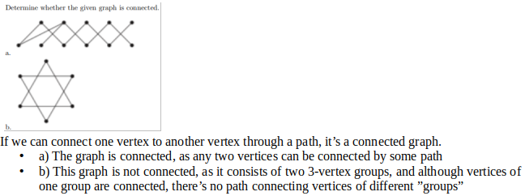

**Some errors in this cheat sheet that have NOT yet been corrected:**

1. In the isomorphic picture, I say “They are isomorphic because they have the same number of vertices and edges” but this is WRONG
   * In order for something to be isomorphic, it must have same number of vertices, edges, AND degrees
   * Therefore, change that to “They MIGHT BE isomorphic because they have the same number of vertices and edges”

2. I did the math wrong for the strong induction question for the base case of a0.

3. For the strong induction question, P(k + 1) = ak-1 + 2ak-2 is WRONG

* It should be P(k + 1) = ak + 2ak-1
* Fortunately, the rest of the mathematics was correct so I got the answer correct for that just the small notation was incorrect which isn’t a big deal

4. Complete bipartite graph notation is “Km, n” which I didn’t add